# CS 255 System Design Document Template

This template lays out all the different sections that you need to complete for Project Two. Each section has guidance to prompt your thinking. You will need to continually reference the interview transcript as you work to make sure that you are addressing your client’s needs. There is no required length for the final document. Instead the goal is to complete each section based on what your client’s needs are. Remove this note when you are finished, and replace all bracketed text with the relevant information.

## UML Diagrams

### UML Use Case Diagram

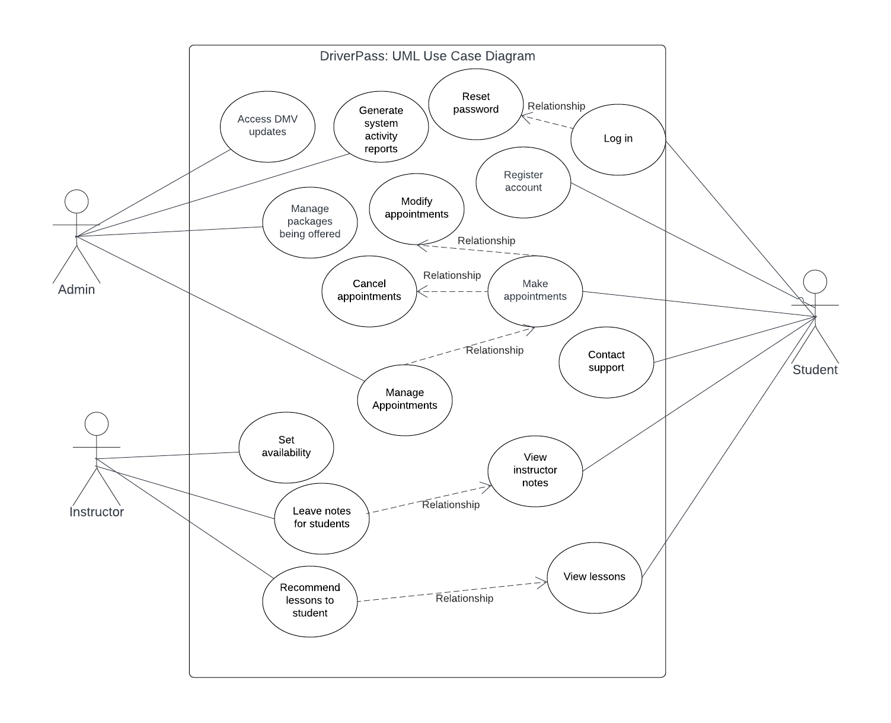

### UML Activity Diagrams

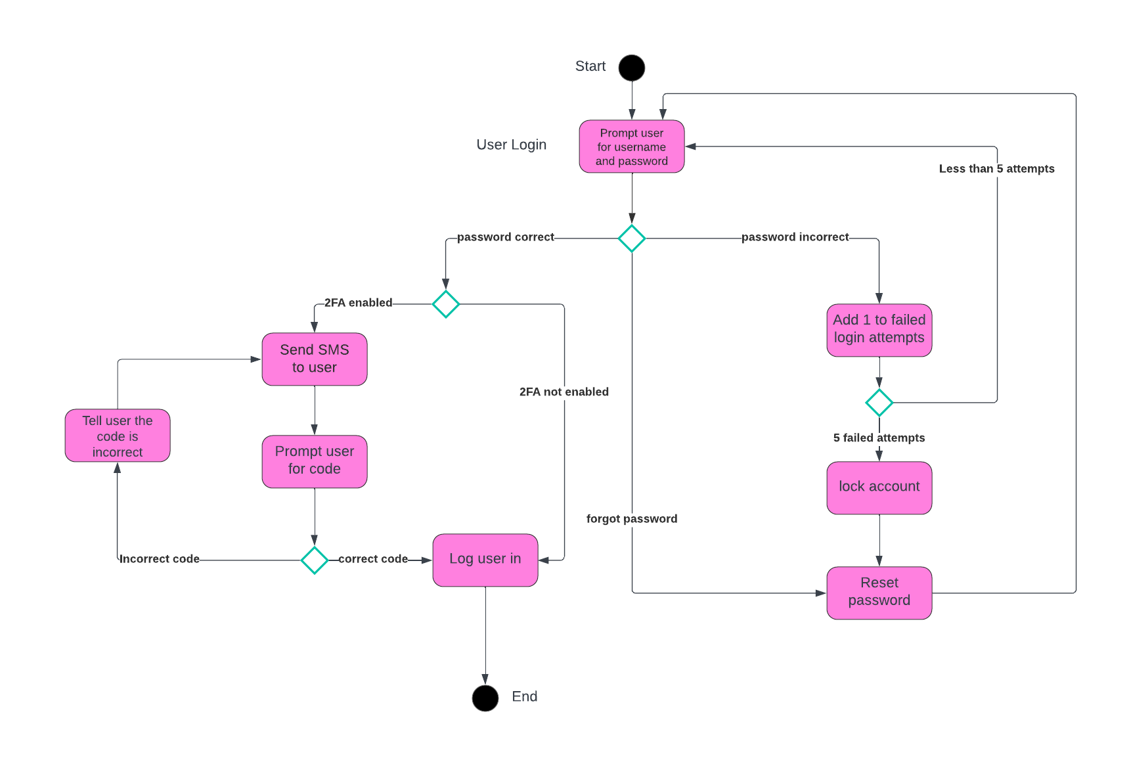

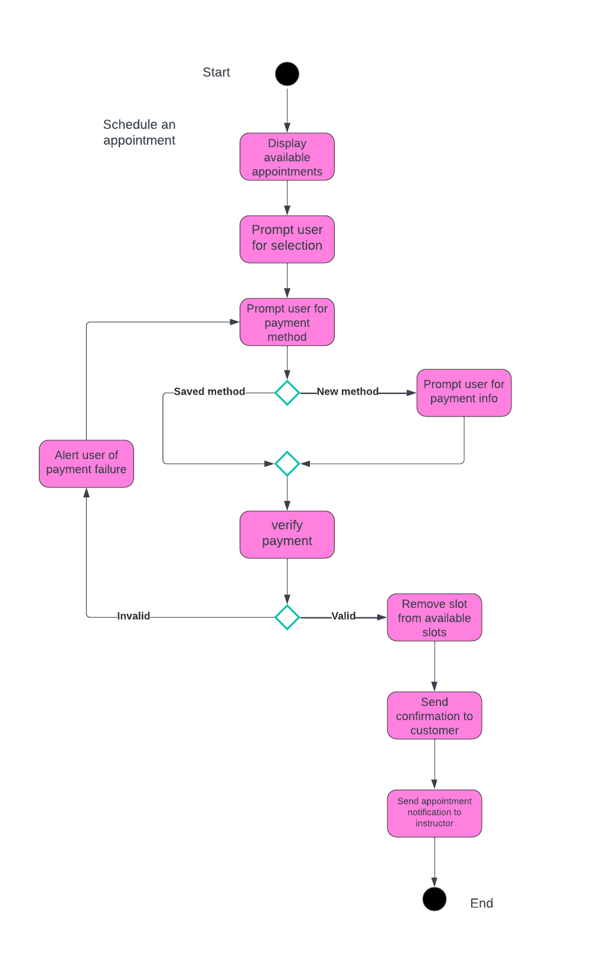

### UML Sequence Diagram

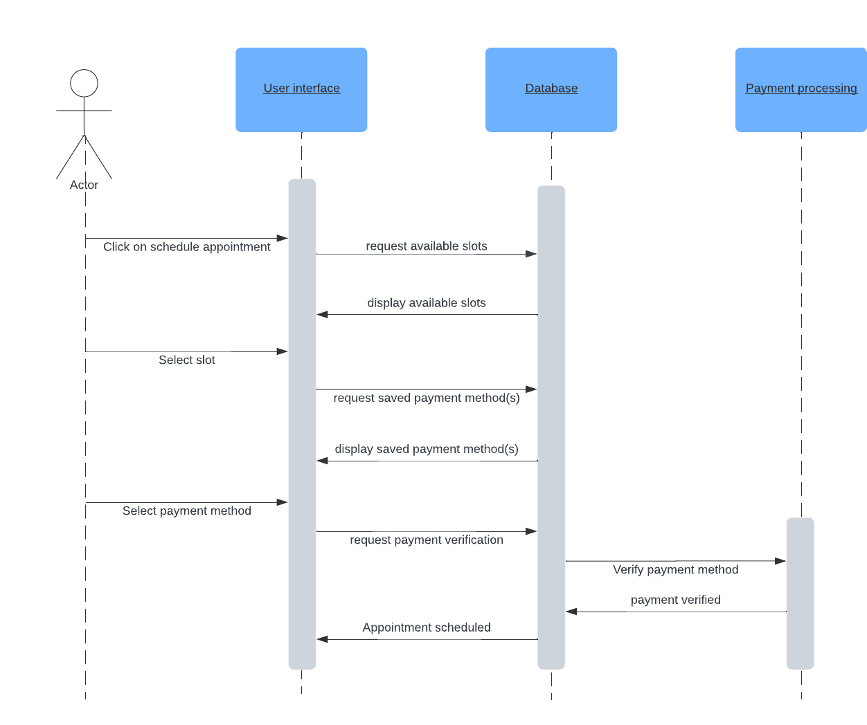

### UML Class Diagram

*[You were asked to create a class diagram based on the different classes and attributes needed for your system design. You are* ***not*** *required to include methods, but you may if you wish. Please insert your class diagram here. Check to make sure that you included appropriate components and symbols and that your design meets the client’s requirements.]*

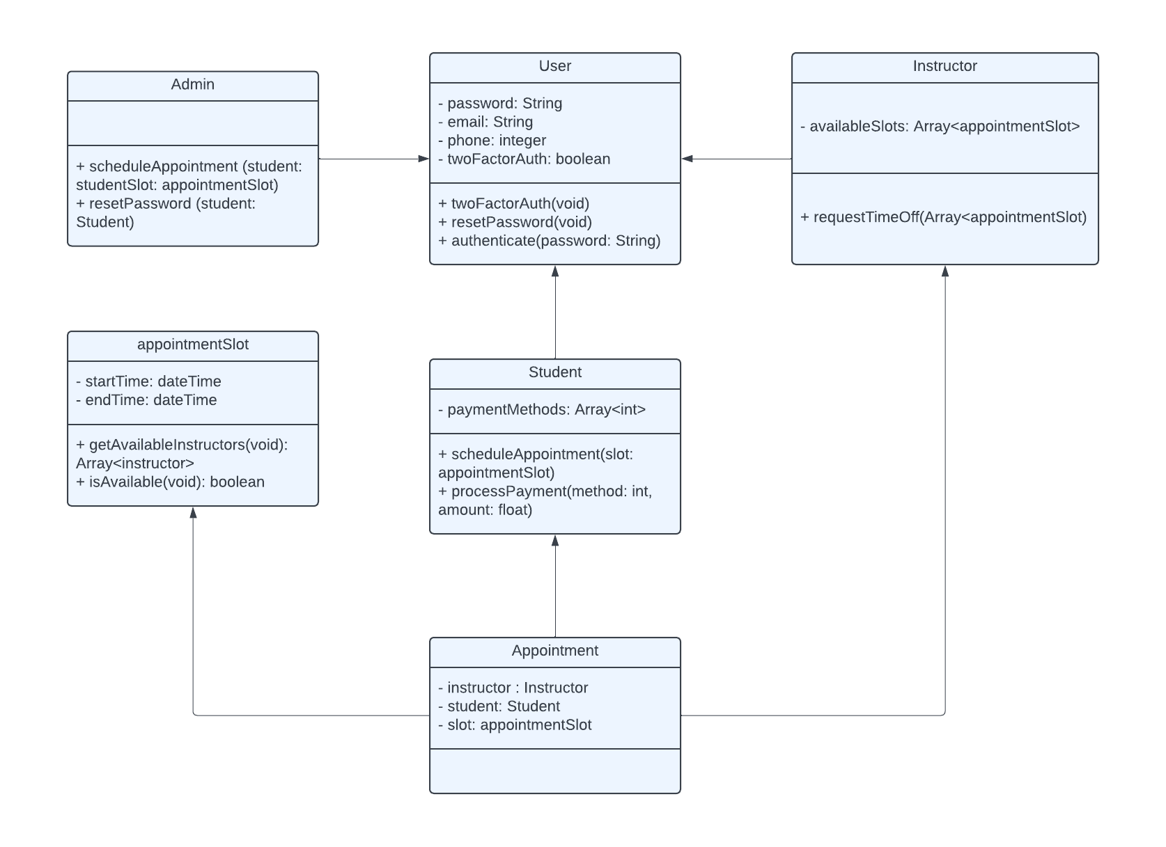

## Technical Requirements

* Backend database to store user information and system information such as appointments, instructors, students etc.
* Payment processing service which would need to be linked to the website’s backend database
* Responsive Front end website which would allow both instructors and students to access the services the system would provide
* Stable internet connection and a device which can reliably access various internet browsers